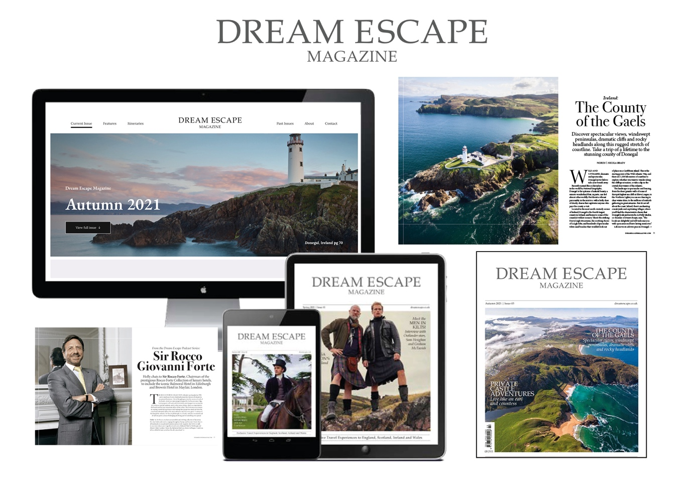
Our quarterly magazine, offers the ultimate in exclusive and inspirational customised travel experiences, to England, Scotland, Ireland and Wales. With seasonally themed content and support from our preferred partners, we aim to showcase the very best destinations, accommodation and cultural events, Dream Escape has to offer.
DISTRIBUTION & READERSHIP
Following a successful digital launch on subscription platforms, Dream Escape Magazine is generating digital reads of over 15,000+ per issue.. It is available on American Airlines, Virgin Atlantic, Readly, Press Reader, and Issuu. It can also be found on media walls in London Heathrow Airport, in luxury hotels across the world and as an advertising partner, you will also have the option to include a supply of magazines in your own property.
With an impressive global contact list, including our 12,000+ database of travel advisors, key travel consortia, tourist boards, travel writers and high net-worth individuals, Dream Escape certainly offers unrivalled opportunities to businesses looking to engage with, and inspire, the North American & International travel industry. From this summer, Dream Escape Magazine will also be sold through selected Barnes & Noble Bookstores throughout the US.

Online and mobile optimised:
Magazine content is optimised online and distributed through our website, e-newsletters and social media channels bringing the Dream Escape Magazine to life. Our monthly e-mailer open rates are above the industry average at 21.6% and our stories are proving very popular and are regularly picked up and shared by leading digital publishing platform ISSUU, exposing our content to another potential 80+million reader

Magazine Features
Each quarterly issue is brimming with on-trend travel content, to include seasonal events, travel news, unique destinations and unforgettable experiences – here is a quick look at just some of our regular features :

Travel News
Stay up-to0date with ‘What’s New’ and exciting within the UK & Ireland’s luxury hotel and hospitality sector with our regular ‘Hotel Bulletin’ spread.

Destination Features
From an idyllic private island to acres of woodland countryside, mountain ranges and the longest defined coastal touring route in the world – each issue includes a plethora of inspiring destinations.

Exclusive Accommodation
Features include interviews with custodians of historic exclusive use properties, remote private lodges to unique castle hotels and luxury retreats.

Interviews
From Head Chefs with world-renowned Michelin-star restaurants, to Royal Warrant hilding British craftsman, and our brand new podcast series, we are spoilt for choice with Dream Escape connections, and people to talk with.

Don’t just take our word for it …..

“Be inspired by the new Dream Escape Magazine, check out this story …” ISSUU

“ [the magazine…] is incredibly relevant and beautiful all at the same time” Susannah Lurie, Dorchester Collection
“such a gorgeous magazine, our clients love it. Amazing!” Beth Flowers, Brownell Travel

ADVERTISING
OPPORTUNITIES & SPECIFICATIONS
Find the best option for your business
with our choice of advertisement sizes
and editorial opportunities:

COVER POSITION
INSIDE FRONT/INSIDE BACK/
OUTSIDE BACK:
Trim: 230 mm wide x 290 mm high
Bleed: 236 mm wide x 296 mm high
PRICE £750 + VAT

DOUBLE PAGE SPREAD
INSIDE FRONT:
Trim: 460 mm wide x 290 mm high
Bleed: 466 mm wide x 296 mm high
PRICE £900 + VAT

FULL PAGE
DISPLAY:
Trim: 230 mm wide x 290 mm high
Bleed: 236 mm wide x 296 mm high
PRICE £550 + VAT

PRE-AGREED CONTENT
THREE PAGE FEATURE:
4-5 Images and 900 words of text
Designed into our house style
PRICE £1,200 + VAT

Copy Deadlines :

Autumn Issue 2022 | Winter Issue 2022/23 | Spring Issue 2023 | Summer Issue 2023
SEP/OCT/NOV | DEC/JAN/FEB | MAR/APR/MAY | JUNE/JULY/AUG
Artwork deadline | Artwork deadline | Artwork deadline | Artwork deadline
10th August 2022 | 09th Nov 2022 | 07th Feb 2023 | 5th May 2023

Get in touch with Sue Morris for more information & to book your slot
Spaces are limited and sold on a first come first served basis
sue@dreamescape.co.uk

